**Idea:**

**An App which can remind you to take medicines on time. It’s easy to use. App will scan the prescription and create the notification calendar for user.**

**Medicine Tracker**

1. This App will be available only on Android only.
2. This is medicine alarming application which will buzz at the specified time with medicine name and its picture. Picture will be scroll on the screen just like screen-saver.

Below are the proposed screens along with the responsibility.

**Application Opening Screen:-**

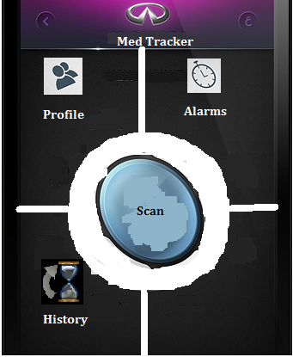

* User will click “Scan”.
* Application will open Camera.
* User scans the prescription. Once done application will close cam.
* Application will open alarms page.

**Alarms Page:-**

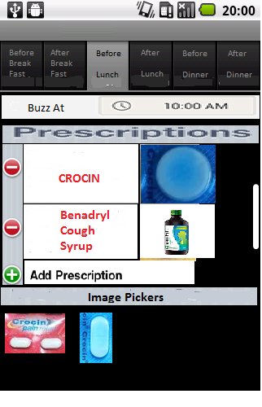

* Based on scanned result
* Application will pre-populate the relevant tabs.
* User will enter appropriate time for notification.
* User can manually add the medicine also.
* For medicines with multiple images, image picker will populate all available images.
* System will display all non-identifiable medicines along with their nearest match and picture of nearest match.

**User Profile**:-

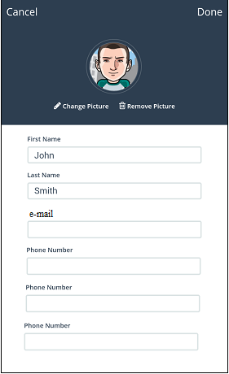

* User Info Page
* Basic info Name and E-Mail id will be stored in the system.
* Three notification numbers will be stored per user which will get SMS notification once the user sets off the medicine alarms(after taking medicine).

**Snooze:-**



* Snooze Page Info
* At the specified alarm time, application will start a screensaver of all the medicines to be taken at that time.
* Once user takes the medicines, it will click DONE button.
* On clicking done button, application will notify the three configured phones numbers (on user profile page) that the user has taken its medicine.

**User History Page**:-

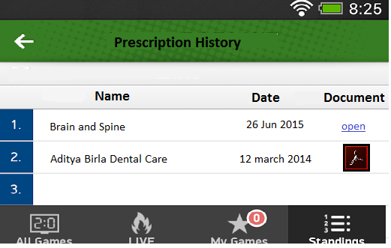

* Prescription History
* All the prescriptions will be saved (after user concenses).
* User can see the available prescription or download the older one when needed.